SOUND CONTROLLED SWITCH (CLAP CIRCUIT)

AIM:
To design and implement a sound-controlled switch that turns ON/OFF an LED or appliance using clap sound.

Components Required

Theory
A traffic signal controller is used to manage vehicle movement at intersections.
In this circuit, the 555 timer generates clock pulses in astable mode. These pulses are fed to the CD4017 counter, which activates its outputs sequentially. Each output corresponds to a specific traffic light condition (Green, Yellow, Red). The signals switch automatically in a cyclic order, allowing one direction at a time.

Working Principle
- The 555 timer produces continuous clock pulses
- The CD4017 counter advances one output per pulse (Q0–Q7)
- Each output controls LEDs for different roads
- Only one road gets green at a time, others remain red
- The sequence repeats continuously

Circuit Diagram
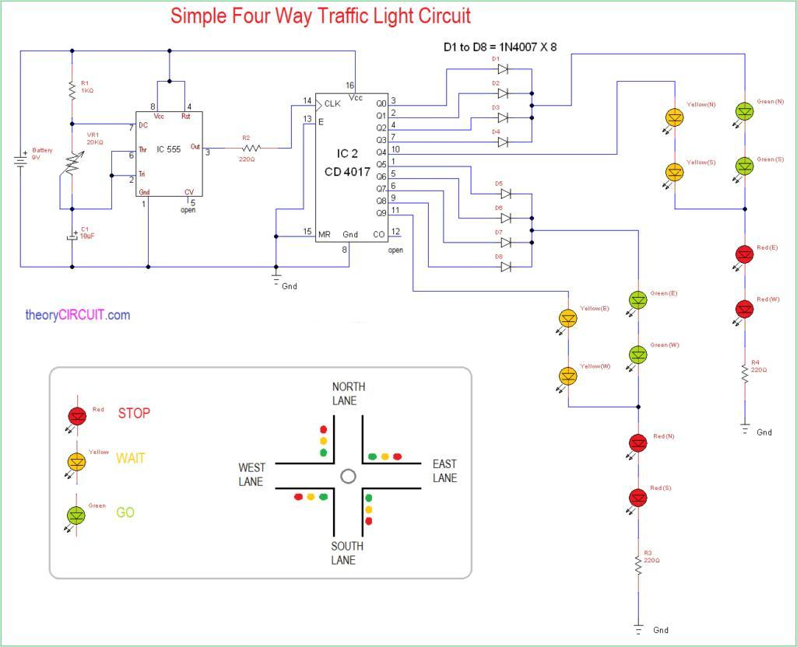

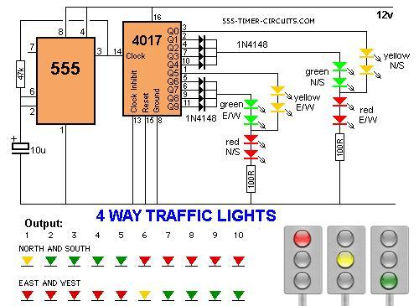

State Table

STEP | ROAD 1 | ROAD 2 | ROAD 3 | ROAD 4
Q0 | GREEN | RED | RED | RED
Q1 | YELLOW | RED | RED | RED
Q2 | RED | GREEN | RED | RED
Q3 | RED | YELLOW | RED | RED
Q4 | RED | RED | GREEN | RED
Q5 | RED | RED | YELLOW | RED
Q6 | RED | RED | RED | GREEN
Q7 | RED | RED | RED | YELLOW

Procedure
- Connect the 555 timer in astable mode
- Connect its output to clock input of CD4017
- Connect LEDs to outputs Q0–Q7 through resistors
- Arrange LEDs to represent 4 roads
- Provide power supply
- Observe sequential switching of LEDs

Result
The 4-way traffic signal controller was successfully designed and implemented. The LEDs switched sequentially, simulating real-time traffic control.

Applications
- Traffic control at road intersections
- Smart traffic systems
- Industrial automation
- Educational demonstrations
- Railway crossing systems
Limitations:
- The 555 timer has timing drift with temperature; a microcontroller (like Arduino/ATmega) offers precision.
- No vehicle detection real systems use inductive loop sensors or IR sensors to adapt green time dynamically.
- Fixed timing doesn't account for peak hours vs. off-peak adaptive algorithms (like Webster's formula) solve this.
- Without pedestrian signal integration a real system needs a separate pedestrian phase.

